Practice 8. Deliverable

**PERFORMANCE AND CONFIGURATION OF MEMORY MODULES**

|  |
| --- |
| Name and surname:  GROUP: |

## Proposed exercises: Obtaining the characteristics of SDRAM memory modules

Information provided by the CPU-Z program for the example computer under the SPD tab.

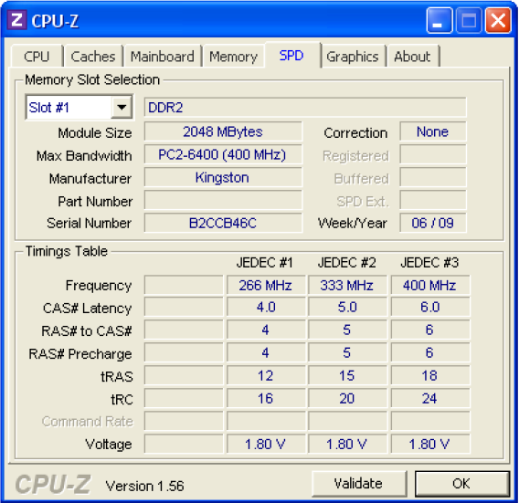

Figure 3. Memory module characteristics provided by the manufacturer

Timing parameters of the computer memory example:

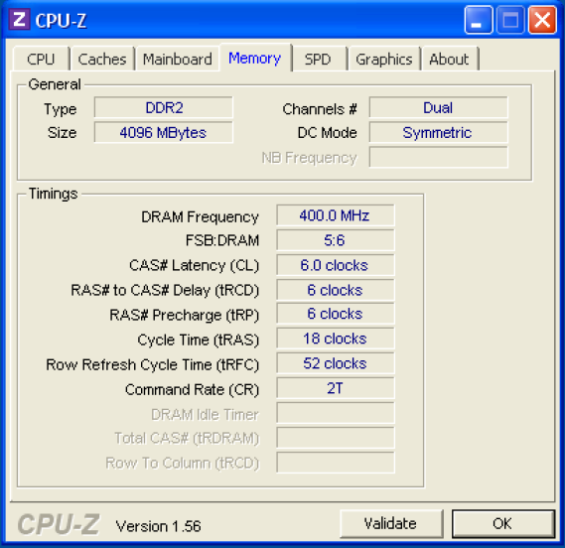

Figure 4. Main timing parameters of the memory module according to its working frequency

**PART I. Analysis of the memory configuration of the example equipment**

1. From the data provided by the data sheet of the modules (file KVR800D2N6_2G.pdf) and the CPU-Z program (Figures 3 and 4), complete in the following table. Recall that Figure 3 shows information only of one slot, but there is a second one with identical characteristics.

|  |  |
| --- | --- |
| ***Information about the capacity and organization of memory modules*** | |
| Total number of DIMMs |  |
| Size of the DIMMs that compose the main memory  *Expressed in MB* |  |
| Total size of available main memory  *Expressed in GB* |  |
| Capacity in words x word_size of the DIMMs |  |
| Number of chip rows in each module |  |
| Module memory chip size  *(Expressed in words × word_size)* |  |
| Total number of memory chips contained in a module |  |
| Type of module memory chips  *(DDR, DDR2, DDR3, DDR4)* |  |
| ***Information about work frequency and bandwidth of the modules*** | |
| Clock frequency of the external buses of the modules used **in the computer on which CPU-Z was executed** |  |
| Peak bandwidth of the modules used **in the computer on which CPU-Z was executed**  *Expressed in MB/s* |  |
| Standard nomenclature of the modules used **in the computer in which CPU-Z was executed**  *(PC-xx00, PC2-xx00, PC3-xxx00, PC4-xxx00)* |  |
| Maximum clock frequency to which the external buses of the module memory chips could work |  |
| Maximum transfer rate that the memory modules could reach (words that are transferred per second)  *Expressed in millions of transfers per second (MT/s)* |  |
| Peak bandwidth that the memory modules could reach  *Expressed in MB/s* |  |

1. The data sheet indicates that the module memory chips are of the DDR2-800 type. What does the value 800 mean?
2. From the data provided by the modules data sheet (KVR800D2N6_2G) and by the CPU-Z program, complete the following table with the values of the main timing parameters:

|  |  |  |
| --- | --- | --- |
|  | **ns** | **Clock cycles** |
| **tCK (clock cycles)** |  |  |
| **TRAS** |  |  |
| **TRC** |  |  |
| **TRFC** |  |  |

***Note****: The number of clock cycles must always be an integer, so, if needed, it must be rounded to the upper integer. In the case that the clock cycle (tCK) is not explicitly indicated in the data sheet, it should be calculated from the frequency at which the memory module has been programmed through its SPD*

1. Give the timing of the SDRAM chip in the standard format established by JEDEC (*Joint Electron Device Engineering Council*): JEDEC #X: CL- TRCD - TRP- TRAS

|  |  |  |  |  |  |  |  |  |  |  |
| --- | --- | --- | --- | --- | --- | --- | --- | --- | --- | --- |
| JEDEC | # |  |  |  |  |  |  |  |  |  |

1. What would be the value of CL if the working frequency of the external buses of the memory modules is 500 MHz?
2. What would be the access time of the memory modules accounted from the start of the read operation (sending the ACTIVATION command) until the first data of the block is obtained?

|  |  |  |
| --- | --- | --- |
|  | **Clock cycles** | **ns** |
| **Access time** |  |  |

**PART II. Read chronogram for 3 four-word blocks. ►** Using the data shown in Figure 2 and the timing parameters obtained in Part I, represent on the chronogram the timing of: i) the successive command issue, ii) the corresponding row and column addresses and, iii) the data transfer corresponding to the access to 3 blocks belonging to different rows of the same bank. The commands are: ACTIVATION (A) and READ (R). The address can be rows (Fi) or columns (Ci), where the subscript indicates the order number of the block (0 ... 2) to which they refer. Finally, the data will be expressed as Di, where the subscript i refers to the word (0 ... 3) within each of the blocks. In addition, **the clock cycles in which precharges are performed must be marked with a (P) on the command line.** Remember that since it is a DDR SDRAM, two words are transferred in each clock cycle. ***Note****: It is not necessary to represent the issue of the NOP commands*

|  |  |  |  |  |  |  |  |  |  |  |  |  |  |  |  |  |  |  |  |  |  |  |  |  |  |  |  |  |  |  |  |  |  |  |  |  |
| --- | --- | --- | --- | --- | --- | --- | --- | --- | --- | --- | --- | --- | --- | --- | --- | --- | --- | --- | --- | --- | --- | --- | --- | --- | --- | --- | --- | --- | --- | --- | --- | --- | --- | --- | --- | --- |
|  | T1 | T2 | T3 | T4 | T5 | T6 | T7 | T8 | T9 | T10 | T11 | T12 | T13 | T14 | T15 | T16 | T17 | T18 | T19 | T20 | T21 | T22 | T23 | T24 | T25 | T26 | T27 | T28 | T29 | T30 | T31 | T32 | T33 | T34 | T35 | T36 |
| **Command** |  |  |  |  |  |  |  |  |  |  |  |  |  |  |  |  |  |  |  |  |  |  |  |  |  |  |  |  |  |  |  |  |  |  |  |  |
|  |  | | | | | | | | | | | | | | | | | | | | | | | | | | | | | | | | | | | |
| **Address** |  |  |  |  |  |  |  |  |  |  |  |  |  |  |  |  |  |  |  |  |  |  |  |  |  |  |  |  |  |  |  |  |  |  |  |  |
|  |  | | | | | | | | | | | | | | | | | | | | | | | | | | | | | | | | | | | |
| **Data** |  |  |  |  |  |  |  |  |  |  |  |  |  |  |  |  |  |  |  |  |  |  |  |  |  |  |  |  |  |  |  |  |  |  |  |  |

|  |  |  |  |  |  |  |  |  |  |  |  |  |  |  |  |  |  |  |  |  |  |  |  |  |  |  |  |  |  |  |  |  |  |  |  |  |
| --- | --- | --- | --- | --- | --- | --- | --- | --- | --- | --- | --- | --- | --- | --- | --- | --- | --- | --- | --- | --- | --- | --- | --- | --- | --- | --- | --- | --- | --- | --- | --- | --- | --- | --- | --- | --- |
|  | T37 | T38 | T39 | T40 | T41 | T42 | T43 | T44 | T45 | T46 | T47 | T48 | T49 | T50 | T51 | T52 | T53 | T54 | T55 | T56 | T57 | T58 | T59 | T60 | T61 | T62 | T63 | T64 | T65 | T66 | T67 | T68 | T69 | T70 | T71 | T72 |
| **Command** |  |  |  |  |  |  |  |  |  |  |  |  |  |  |  |  |  |  |  |  |  |  |  |  |  |  |  |  |  |  |  |  |  |  |  |  |
|  |  | | | | | | | | | | | | | | | | | | | | | | | | | | | | | | | | | | | |  |  |  |  |  |  |  |  |  |  |  |  |  |
| **Address** |  |  |  |  |  |  |  |  |  |  |  |  |  |  |  |  |  |  |  |  |  |  |  |  |  |  |  |  |  |  |  |  |  |  |  |  |
|  |  | | | | | | | | | | | | | | | | | | | | | | | | | | | | | | | | | | | |
| **Data** |  |  |  |  |  |  |  |  |  |  |  |  |  |  |  |  |  |  |  |  |  |  |  |  |  |  |  |  |  |  |  |  |  |  |  |  |

|  |  |  |  |  |  |  |  |  |  |  |  |  |  |  |  |  |  |  |  |  |  |  |  |  |  |  |  |  |  |  |  |  |  |  |  |  |
| --- | --- | --- | --- | --- | --- | --- | --- | --- | --- | --- | --- | --- | --- | --- | --- | --- | --- | --- | --- | --- | --- | --- | --- | --- | --- | --- | --- | --- | --- | --- | --- | --- | --- | --- | --- | --- |
|  | T73 | T74 | T75 | T76 | T77 | T78 | T79 | T80 | T81 | T82 | T83 | T84 | T85 | T86 | T87 | T88 | T89 | T90 | T91 | T92 | T93 | T94 | T95 | T96 | T97 | T98 | T99 | T100 | T101 | T102 | T103 | T104 | T105 | T106 | T107 | T108 |
| **Command** |  |  |  |  |  |  |  |  |  |  |  |  |  |  |  |  |  |  |  |  |  |  |  |  |  |  |  |  |  |  |  |  |  |  |  |  |
|  |  | | | | | | | | | | | | | | | | | | | | | | | | | | | | | | | | | | | |  |  |
| **Address** |  |  |  |  |  |  |  |  |  |  |  |  |  |  |  |  |  |  |  |  |  |  |  |  |  |  |  |  |  |  |  |  |  |  |  |  |
|  |  | | | | | | | | | | | | | | | | | | | | | | | | | | | | | | | | | | | |
| **Data** |  |  |  |  |  |  |  |  |  |  |  |  |  |  |  |  |  |  |  |  |  |  |  |  |  |  |  |  |  |  |  |  |  |  |  |  |

**PART III. VOLUNTARY**

**Analysis of the student's computer memory configuration**

To carry out this part of the practice, the student must install the CPU-Z program on his/her personal computer, either from the file provided in PoliformaT or through the link: [http://www.cpuid.com/softwares/cpu -z.html](http://www.cpuid.com/softwares/cpu%20-z.html)

The file must be executed on the student's computer to know the most important characteristics of the system. The obtained memory information must be completed with the data extracted from the data sheet provided by the chip manufacturer. Commonly, this data sheet is easy to obtain through a query in any search engine. For example, for a memory manufactured by Kingston whose identification is KHX1600C10D3B1/8G (Part Number), you can type in any search engine "Kingston KHX1600C10D3B1/8G" to obtain the corresponding data sheet.

1. Copy and paste the screenshots corresponding to the SPD and Memory labels obtained from the execution of CPU-Z on your computer, equivalent to those shown in Figures 3 and 4.
2. From the data provided by the CPU-Z program about the memory configuration of the computer in which it was installed, complete the table below:

|  |  |
| --- | --- |
| Identification of the memory module provided by the manufacturer |  |
| Total number of DIMMs |  |
| Total size of available main memory  *Expressed in GB* |  |
| Clock frequency of the external buses of the SDRAM modules  *Expressed in MHz* |  |
| Clock cycle to which the external buses of the SDRAM modules work  *Expressed in ns* |  |
| Peak bandwidth of the SDRAM modules  *Expressed in MB/s* |  |
| Standard nomenclature of the modules used in the computer analyzed  *(PC-xx00, PC2-xx00, PC3-xxx00, PC4-xxx00)* |  |

1. Represent the timing of the SDRAM chip in the standard format established by JEDEC (*Joint Electron Device Engineering Council*): JEDEC #X: CL- TRCD - TRP- TRAS

|  |  |  |  |  |  |  |  |  |  |  |
| --- | --- | --- | --- | --- | --- | --- | --- | --- | --- | --- |
| JEDEC | # |  | : |  | -- |  | -- |  | -- |  |

1. What would be the access time of the memory modules counted from the start of the read operation (sending the ACTIVATION command) until the first data of the block is obtained?

|  |  |  |
| --- | --- | --- |
|  | **Clock cycles** | **ns** |
| **Access time** |  |  |

1. Search for the data sheet of the memory modules installed in the analyzed equipment according to CPU-Z.

***Note****: Occasionally, the memory identifier offered by CPU-Z does not correspond to the real one, which can be observed by opening the device and examining the legend contained on the installed DIMMs. If this operation can be easily carried out, please indicate below the authentic identification of the modules*

1. Based on the data sheet of the memory modules you have located (according to the identifier offered by CPU-Z), fill in the table below:

|  |  |
| --- | --- |
| Capacity in words x word_size of the DIMMs |  |
| Number of chip rows in each module |  |
| Total number of memory chips contained in a module |  |
| Module memory chip capacity  *(Expressed in words × word_size)* |  |
| Type of module memory chips  *(DDR, DDR2, DDR3, DDR4)* |  |
| Maximum clock frequency to which the external buses of the module memory chips could work |  |
| Maximum transfer rate that the memory modules could reach (words that are transferred per second)  *Expressed in millions of transfers per second (MT/s)* |  |
| Peak bandwidth that the memory modules could reach  *Expressed in MB/s* |  |